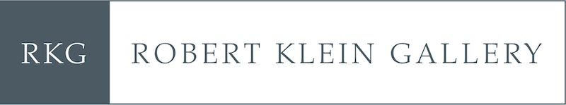

D R A F T  
For Immediate Release

**ROBERT KLEIN GALLERY TO PRESENT**

***THE GIFT***

**HAN FENG**

**JANUARY 18 – FEBRUARY __, 2021**

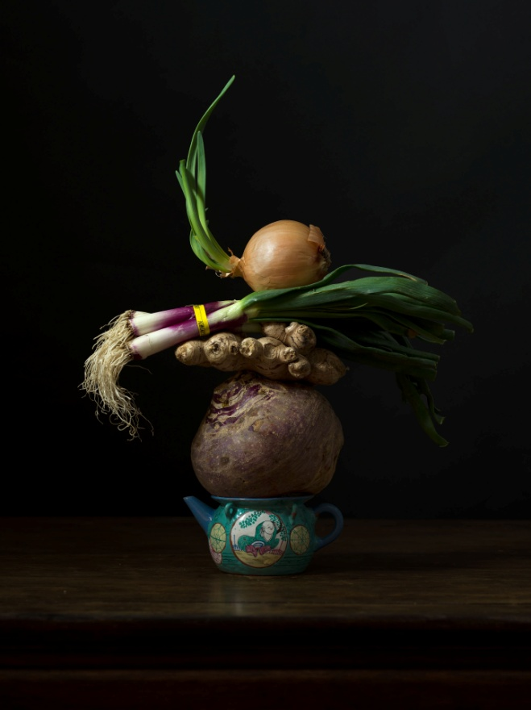

BOSTON— Robert Klein Gallery, in partnership with M97 Gallery, is pleased to present a new exhibition of photographs by New York and Shanghai-based artist and designer Han Feng. The exhibition will be on view from January 18 through March XX, 2021, at Robert Klein Gallery and online (add link). The exhibition, entitled *The Gift*, presents a series of 20 artfully- and poetically-conceived still lifes from 2020, created while Han Feng was experimenting in her New York City studio during the pandemic.

A celebrated fashion and costume designer, Han Feng began working in photography several years ago when colleagues and friends complimented her on her eye for the medium and challenged her to pick up a camera. Another friend, American photographer Lois Conner, helped her learn the fundamentals of the camera, and before long she was making landscapes. When the pandemic hit, she turned to combining meaningful and ephemeral objects from her kitchen—and Conner and other artists and curator friends noted that she had found her photographic voice.

*The Gift* marks Han Feng’s first exhibition of her fine art photographs. The title of the exhibition comes from her love of ceramics, cuisine, and photography. All the fruits and vegetables in the images were sourced from local specialty and farmers markets in New York City and many of the ceramic objects used in her photographs are gifts from artists around the world she keeps in her studio. “The earth gives us these beautiful even ordinary things, and I love to share them with friends,” she says. Intimate dinner parties she hosts at her studios in New York and Shanghai build on classic Chinese dishes with a touch of western fusion, much like her still life assemblages.

“During this strange period, I was looking at the many stones, rocks, sculptures, vases, and antiques I have collected from China and the U.S.,” said Han Feng recently. “I began to assemble them and create a small stage on a family table that’s over 100 years old. It was almost like making a Chinese soup with lots of ingredients. Other photographers, artists, curators, and friends were very positive about the work, and it really touched me and kept me going. There is often a fragile moment where there is the chance that all the objects could fall down and sometimes during a shoot they would. There is a lot of surprise, fun and joy in the images.”

**ABOUT HAN FENG**

Han Feng grew up in Nanjing and Hangzhou, China, and received her education from the China Academy of Art in Hangzhou in the early 1980s. She moved to New York in 1985 and launched her first ready-to-wear collection at Bryant Park in New York in 1993. She made her costume design debut with Anthony Minghella’s *Madama Butterfly* at the English National Opera, London, and the Metropolitan Opera, New York.

Han Feng's clothing, design, and art installations have been featured in major exhibitions at the Victoria and Albert Museum, London; Neue Galerie and Cooper-Hewitt National Design Museum, New York, among others.

Han Feng finds inspiration in her exploration of highly-refined textures, materials and craftsmanship. She has long been a champion and collector of contemporary Chinese art, collaborating closely with many artists on exciting discoveries to combine art and design, leading up to the opening of Han Feng Art Space in Shanghai in November 2017. She lives and works in New York and Shanghai.

**ABOUT ROBERT KLEIN GALLERY**

[Robert Klein Gallery](http://www.robertkleingallery.com) ranks among the world's most prestigious showrooms of fine art photography. Celebrating its 40th anniversary this year, the gallery has developed an extensive and ever-changing inventory of 19th century, 20th century, and contemporary photographs. Participating in art fairs such as Art Basel, The Armory Show, Paris Photo, The Photography Show presented by AIPAD, Photo London, Intersect Aspen, and Photo LA, Robert Klein Gallery provides its contemporary artists with national and international exposure while exhibiting works by recognized masters such as Sebastião Salgado, Man Ray, Diane Arbus and Francesca Woodman. With decades of experience and a profound knowledge base, the gallery staff is committed to serving as a resource for both novice and seasoned collectors. Located at 38 Newbury Street in Boston, Robert Klein Gallery is currently open by appointment only. To contact the gallery please email [info@robertkleingallery.com](mailto:info@robertkleingallery.com) or call 617-267-7997.

###

**PRESS CONTACT:**

Nicole Straus Public Relations

Nicole Straus, 631-369-2188, 917-744-1040, [nicole@nicolestrauspr.com](mailto:nicole@nicolestrauspr.com)

Margery Newman, 212-475-0252, [MargeryNewman@gmail.com](mailto:MargeryNewman@gmail.com)

Image: Han Feng, *The Gift No. 15,* 2020